

School of Computing
Department of Computer Science and Engineering

CERTIFICATE
This is to certify that the project work entitled “Smart Disease Prediction System with Model Ensemble” is submitted by
CH. Sasi Kanth (24B11CS071)
L.Krishna Manohar (24B11CS250) T.Vijay kumar (24B11CS429)
T. Venkatesh (24B11CS443)

in partial fulfilment of the requirements for the award of the B.Tech degree in Computer Science and Engineering for the academic year 2026-27.

Project Guide  Dr. B. Sindhu Assistant Professor Department of CSE  Aditya University | Head of the Department  Dr. Phani Sridhar Head of the Department Department of CSE  Aditya University

DECLARATION
We hereby declare that the project entitled Smart Disease Prediction System with Model Ensemble is original and is submitted to Aditya University ,Surempalem in partial fulfilment of the requirements for the award of the B.Tech degree in Computer Science and Engineering. We further declare that this project work has not been submitted, either in full or in part, for the award of any degree in this or any other institution. We also confirm that this work complies with the Institutional Academic Integrity and AI Usage Policy.
Place: Surempalem
Date:

By
CH. Sasi Kanth (24B11CS071)
L.Krishna Manohar (24B11CS250) T.Vijay kumar (24B11CS429)
T. Venkatesh (24B11CS443)

ACKNOWLEDGEMENT
It is with immense pleasure that we express our sincere gratitude to our Cornerstone Project Guide, Dr. B. Sindhu, Assistant Professor, who has guided us throughout the project. Their valuable support, encouragement, and guidance have greatly contributed to the successful completion of this work.
We would like to thank our Deputy Heads of the Department, Dr. Chandra Sekhar K, Associate Professor; Dr. Hari J, Associate Professor; and Dr. Siva Satya Prasad P, Assistant Professor, Department of CSE, for their support and valuable suggestions.
Our deepest thanks to our Head of the Department, Dr. A. Phani Sridhar, Assistant Professor & HOD, for their inspiration and for providing all the necessary facilities and resources required for this project.
We also extend our sincere thanks to Dr. M.V. Rajesh, Associate Dean, School of Computing, for his encouragement and support during our project.
We would like to express our sincere gratitude to Dr. G. Suresh, Registrar; Dr. A. Ramesh, Pro Vice-Chancellor (Engineering & Sciences); Dr. S. Rama Sree, Pro Vice-Chancellor (Academics); Dr. M.B. Srinivas, Vice-Chancellor; and Dr. M. Sreenivasa Reddy, Deputy Pro Chancellor and Management, Aditya University, for providing excellent infrastructure and state-of-the-art laboratories.
Finally, we would like to thank the faculty members, lab technicians, non-teaching staff, and our friends who have directly or indirectly supported us in completing this Cornerstone project successfully.

ABSTRACT
The Smart Disease Prediction System with Model Ensemble is a Machine Learning-based application designed to predict potential disease risk using patient health, lifestyle, and medical history information. The system analyzes important health parameters such as age, blood pressure, heart rate, glucose, cholesterol, BMI, smoking habits, physical activity, family history, and previous heart disease to identify patterns associated with disease risk.
The system uses a dataset named disease_data.csv, containing 1,500 patient records and 12 columns. Using Python, Pandas, Scikit-learn, and Pickle, the data is preprocessed through missing-value handling, categorical encoding, feature preparation, and numerical feature scaling where required. The dataset is divided into 80% training data and 20% testing data using a stratified split. Four classification algorithms, Logistic Regression, Decision Tree, Random Forest, and Support Vector Machine (SVM), are trained and evaluated. A Soft Voting Ensemble combines the predictions of multiple models to generate the final risk prediction.
The models are evaluated using Accuracy, Precision, Recall, F1-Score, and ROC-AUC. Based on the results reported in the project presentation, Logistic Regression achieves an accuracy of 89.67%, while the Ensemble model achieves an accuracy of 88.67%. The system provides a console-based interface that collects patient health information and displays an estimated risk percentage with a Low Risk or High Risk classification. This project demonstrates the application of machine learning in preliminary disease-risk assessment and health awareness. The system is an academic prototype and is not intended to replace professional medical diagnosis.

LIST OF CONTENTS

LIST OF FIGURES i
Chapter 1: Introduction 07
  - Introduction 07
  - Problem Statement 07
  - Objectives of the Project 08
  - Scope of the Project 09
Chapter 2: System Overview 10
  - Existing System 10
  - Limitations of Existing System 11
  - Proposed System 12
  - Software Requirements 12
  - Hardware Requirements 10
Chapter 3: System Implementation 13
  - Overview of Development Tools 13
    - Python and Development Environment 13
    - Scikit-learn, Imbalanced-learn and XGBoost 13
    - Running the System 14
  - Dataset Description 14
  - Backend Implementation 15
  - Web Interface 16
  - Repository Organisation 13
Chapter 4: System Architecture 17
  - System Architecture Overview 17
  - Workflow of the Proposed System 18
Chapter 5: Data Preprocessing 19
  - Introduction 19
  - Handling Missing Values 19
  - Data Cleaning 19
  - Outlier Detection and Range Validation 20
  - Feature Engineering / Encoding 20
  - Data Visualization 21
  - Train-Test Split 21
  - Summary 21
Chapter 6: Methodology and Algorithms 22
  - Introduction 22
    - Logistic Regression 22
  - Random Forest 23
  - Support Vector Machine (SVM) 23
  - Soft Voting Ensemble 24
  - Model Evaluation Metrics 24
Chapter 7: Results and Analysis 26
  - Introduction 26
  - Experimental Setup 26
  - Performance Evaluation 26
  - Comparison of Models 27
  - Key Findings 27
Chapter 8: Output Screens 28
  - Assessment Console 28
  - Assessment Result 28
  - Model Performance and Comparision 29
Chapter 9: Conclusion 31
Chapter 10: Future Scope 32
Chapter 11: References 33

LIST OF FIGURES
Fig 4.1: System architecture of RiskLens smart disesase prediction Fig 5.1: Patient health features
Fig 6.1: Mapping of risk score to risk category Fig 8.1: Assessment console
Fig 8.2: Assessment result Fig 8.3: Model comparision

CHAPTER 1
INTRODUCTION

Introduction
Healthcare risk assessment plays an important role in identifying potential diseases at an early stage. Before a health risk can be assessed, several factors such as the patient's age, blood pressure, heart rate, glucose, cholesterol, BMI, lifestyle habits, and medical history need to be considered. Manually analyzing these factors can be time-consuming, and understanding the relationship between different health parameters may be difficult.
Machine Learning is useful for this task because it can analyze historical patient data and identify patterns associated with different risk categories. By training classification models on existing health records, the system can estimate potential disease risk for new patient data. Using multiple machine learning algorithms also allows their performance to be compared, while an ensemble approach combines predictions from multiple models to generate a final risk classification.
his project, the Smart Disease Prediction System with Model Ensemble, implements this approach using Python and machine learning techniques. A dataset containing 1,500 patient records is used to train and evaluate Logistic Regression, Decision Tree, Random Forest, and Support Vector Machine (SVM) classifiers. A Soft Voting Ensemble combines the predictions of multiple models. The system collects patient health and lifestyle information through a console-based interface and displays an estimated risk percentage with a Low Risk or High Risk classification. The project aims to support preliminary disease-risk assessment and health awareness; it is an academic prototype and does not replace professional medical diagnosis.

Problem Statement
Disease-risk assessment requires the analysis of multiple health parameters at the same time. Without a consistent prediction system, understanding the combined effects of age, blood pressure, heart rate, glucose, cholesterol, BMI, lifestyle habits, and medical history can be difficult. Manual assessment may be time-consuming, and simple rule-based methods may not effectively identify complex relationships among different health factors. Different machine learning models may also produce different predictions for the same patient data.

The problem addressed in this project is to develop a machine learning-based system that analyzes patient health and lifestyle information and estimates potential disease risk. The system uses supervised classification algorithms trained on labelled patient data, compares their performance using standard evaluation metrics, and combines predictions through a Soft Voting Ensemble. The final result is presented as an estimated risk percentage and a Low Risk or High Risk classification. The system aims to support preliminary risk assessment and health awareness, but it does not replace professional medical diagnosis.

Objectives of the Project
    - To collect and prepare patient health data for disease-risk prediction.
    - To analyze important health, lifestyle, and medical history features such as age, blood pressure, glucose, cholesterol, and BMI.
    - To preprocess the dataset by handling missing values, encoding categorical features, and scaling numerical features where required.
    - To implement and train multiple Machine Learning classification algorithms, including Logistic Regression, Decision Tree, Random Forest, and Support Vector Machine (SVM).
    - To compare the performance of the trained models using Accuracy, Precision, Recall, F1-Score, and ROC-AUC.
    - To implement a Soft Voting Ensemble that combines predictions from multiple classification models.
    - To develop a simple console-based prediction system that displays an estimated disease-risk percentage and classifies the result as Low Risk or High Risk.

Scope of the Project
The project covers the development of a Machine Learning-based disease-risk prediction system using a dataset containing 1,500 patient records. It includes data preprocessing, feature preparation, training and comparison of Logistic Regression, Decision Tree, Random Forest, and Support Vector Machine (SVM) models, and implementation of a Soft Voting Ensemble. The system uses Python, Pandas, Scikit-learn, and Pickle for data processing, model development, and model storage. A console-based interface collects patient health information and displays an estimated disease-risk percentage with a Low Risk or High Risk classification.

The project focuses on preliminary disease-risk assessment using health, lifestyle, and medical history features. Model performance is evaluated using Accuracy, Precision, Recall, F1-Score, and ROC-AUC. The current scope is limited to the available dataset and the implemented prediction interface. Advanced features such as real-time hospital integration, electronic health record connectivity, user authentication, and deployment as a web or mobile application are outside the current scope. The system is an academic prototype intended to support health awareness and does not replace professional medical diagnosis.

CHAPTER 2
SYSTEM OVERVIEW

Existing System
In the conventional approach, disease-risk assessment is performed by examining a patient's health information, medical history, and lifestyle factors. Healthcare professionals consider parameters such as age, blood pressure, heart rate, glucose, cholesterol, and BMI to understand potential health risks. These parameters may be reviewed individually or combined with clinical knowledge to assess a patient's health condition. Traditional methods may also use predefined rules or individual health indicators to identify possible risk factors.

Limitations of Existing System
    - Time-consuming: Manually analyzing multiple health parameters can take considerable time, especially when several patient records need to be reviewed.
    - Dependence on medical expertise: Interpreting different health indicators and understanding their combined effects may require professional medical knowledge.
    - Limited interaction between variables: Simple rule-based methods may not effectively identify complex relationships among age, blood pressure, glucose, cholesterol, BMI, lifestyle, and medical history.
    - Difficulty in risk identification: Different health conditions may share similar risk factors, making early identification of potential disease risks challenging.
    - Lack of model-based evaluation: Traditional methods may not provide a consistent way to compare predictions using standard machine learning evaluation metrics.
    - Need for automated assessment: A simple system is needed to analyze patient information, apply trained classification models, and provide a quick preliminary disease-risk prediction.

Proposed System
The proposed system, Smart Disease Prediction System with Model Ensemble, uses machine learning algorithms to predict potential disease risk based on patient health, lifestyle, and medical history information. The patient dataset containing 1,500 records is loaded from a CSV file and prepared for model training. Missing values are handled where required,

categorical features are encoded, and numerical features are scaled when necessary. The dataset is divided into 80% training data and 20% testing data using a stratified split. Logistic Regression, Decision Tree, Random Forest, and Support Vector Machine (SVM) classifiers are trained and evaluated. A Soft Voting Ensemble combines predictions from multiple models to generate the final risk prediction.
At runtime, the user enters patient health information through the console-based interface. The system processes the entered values using the same preprocessing steps applied during model training and passes them to the trained models. The system then displays an estimated disease-risk percentage and classifies the result as Low Risk or High Risk. Model performance is evaluated using Accuracy, Precision, Recall, F1-Score, and ROC-AUC. This approach provides a simple and consistent method for preliminary disease-risk assessment and health awareness. The system is an academic prototype, and its predictions must not be used as a substitute for professional medical diagnosis.

Software Requirements
    - Operating System: Windows 10/11 or Linux.
    - Programming Language: Python.
    - Libraries: Pandas, Scikit-learn, Pickle, and other required Python libraries for data preprocessing and machine learning.
    - IDE / Tools: Visual Studio Code, Command Prompt / Terminal.
    - Machine Learning Algorithms: Logistic Regression, Decision Tree, Random Forest, and Support Vector Machine (SVM).
    - Data Format: CSV file (disease_data.csv) for storing patient health records and Pickle files for saving trained models, where implemented.

Hardware Requirements
    - Processor: Intel Core i5 or equivalent (or higher).
    - RAM: 8 GB or higher.
    - Storage: 250 GB, SSD preferred (the project itself needs only a few hundred MB including dependencies).
    - System Type: 64-bit operating system.

CHAPTER 3
SYSTEM IMPLEMENTATION

Overview of Development Tools

Python and Development Environment
Python is used for the development of the Smart Disease Prediction System because it provides useful libraries for data processing and machine learning. The project is developed using Visual Studio Code, while the Command Prompt or Terminal is used to execute the Python programs. Python supports the implementation of data preprocessing, model training, model evaluation, and disease-risk prediction.

scikit-learn, imbalanced-learn and XGBoost
Pandas is used to load and process the patient dataset, while Scikit-learn provides the machine learning algorithms, preprocessing techniques, and evaluation metrics. Logistic Regression, Decision Tree, Random Forest, and Support Vector Machine (SVM) are used to train and compare classification models. The Soft Voting Ensemble combines predictions from multiple models to generate the final risk classification. Pickle is used to save and load trained model objects where implemented. These tools work together to process patient information and estimate potential disease risk.

Running the System
The system follows a sequence of steps, beginning with dataset loading and data preprocessing. The dataset is divided into training and testing sets using an 80:20 stratified split. The classification models are trained on the training data and evaluated on the test data using Accuracy, Precision, Recall, F1-Score, and ROC-AUC. Finally, the trained models are used by the console-based interface to predict disease risk from new patient information.

Dataset Description
The project uses a patient health dataset named disease_data.csv, which contains 1,500 patient records and 12 columns. The dataset includes important health, demographic, lifestyle, and medical history features used for disease-risk prediction. These features include age, gender,

blood pressure, heart rate, glucose, cholesterol, BMI, smoking, physical activity, family history, and heart disease.
The target variable is target, where 0 represents No Risk and 1 represents Risk. The dataset is used to train and evaluate the machine learning classification models. Before training, the data is preprocessed by handling missing values where required, encoding categorical features, and scaling numerical features where necessary. The dataset is divided into 80% training data and 20% testing data using a stratified split to maintain the class distribution. The prepared data is then used to train and compare Logistic Regression, Decision Tree, Random Forest, and Support Vector Machine (SVM) models, along with the Soft Voting Ensemble.

Backend Implementation
The backend implementation of the Smart Disease Prediction System is developed using Python. It handles patient health information, prepares the input data, and passes it to the trained machine learning models for disease-risk prediction. The system uses the preprocessing steps and feature format required by the trained models to ensure that the input data is processed consistently.
The prediction process uses Logistic Regression, Decision Tree, Random Forest, and Support Vector Machine (SVM) models. A Soft Voting Ensemble combines predictions from multiple models to generate the final risk estimate. The system calculates the estimated disease-risk percentage and classifies the result as Low Risk or High Risk based on the implemented threshold. A risk probability of 50% or above is classified as High Risk, while a value below 50% is classified as Low Risk.
The Python prediction program, predict.py, collects patient details such as age, gender, blood pressure, heart rate, glucose, cholesterol, BMI, smoking status, physical activity, family history, and previous heart disease. Categorical inputs are converted into the numerical format expected by the trained models, and the processed values are passed to the prediction pipeline. The system then displays the estimated risk percentage and classification through the console interface.
The backend provides the core functionality of the application by connecting patient input, data preprocessing, trained machine learning models, and prediction output. The system is designed

for preliminary disease-risk assessment and health awareness. Its predictions are not a substitute for professional medical diagnosis.

Web Interface
The Smart Disease Prediction System provides a simple console-based interface for entering patient health information and obtaining disease-risk predictions. The interface collects details such as age, gender, blood pressure, heart rate, glucose, cholesterol, BMI, smoking status, physical activity, family history, and previous heart disease.
After receiving the input, the Python program processes the values and passes them to the trained machine learning models. The Soft Voting Ensemble combines predictions from multiple models to generate the final risk estimate. The output displays the estimated disease-risk percentage and classifies the result as Low Risk or High Risk based on the implemented threshold.
The console interface makes the prediction process simple and easy to use. It connects patient input with the trained models and presents the result directly in the terminal. The system is intended for preliminary health-risk assessment and awareness, not as a replacement for professional medical diagnosis.

Repository Organisation
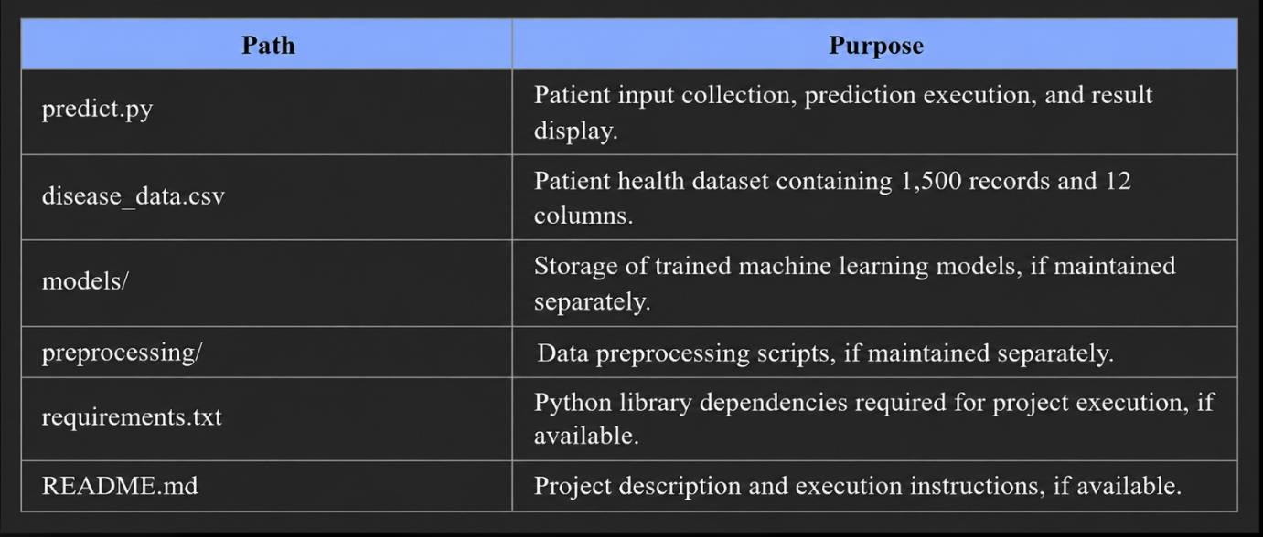

CHAPTER 4
SYSTEM ARCHITECTURE
The Smart Disease Prediction System with Model Ensemble consists of a sequence of stages, beginning with patient dataset collection and ending with disease-risk prediction. The training process loads the dataset, performs data preprocessing, prepares the features, trains multiple classification models, and evaluates their performance on test data. The trained models are then used by the prediction program to process new patient information and generate a risk classification. The complete workflow is summarized stage by stage below.
[ Patient Health Dataset (disease_data.csv) ]
↓
[ Data Preprocessing (missing values, encoding, scaling) ]
↓
[ Feature Preparation (health, lifestyle, medical history) ]
↓
[ Stratified 80/20 Train-Test Split ]
↓
[ Model Training (Logistic Regression, Decision Tree, Random Forest, SVM) ]
↓
[ Model Evaluation (Accuracy, Precision, Recall, F1-Score, ROC-AUC) ]
↓
[ Soft Voting Ensemble ]
↓
Patient Input through Console Interface ]
↓
[ Disease-Risk Prediction and Classification ]
↓
[ Risk Percentage and Low Risk / High Risk Output ]

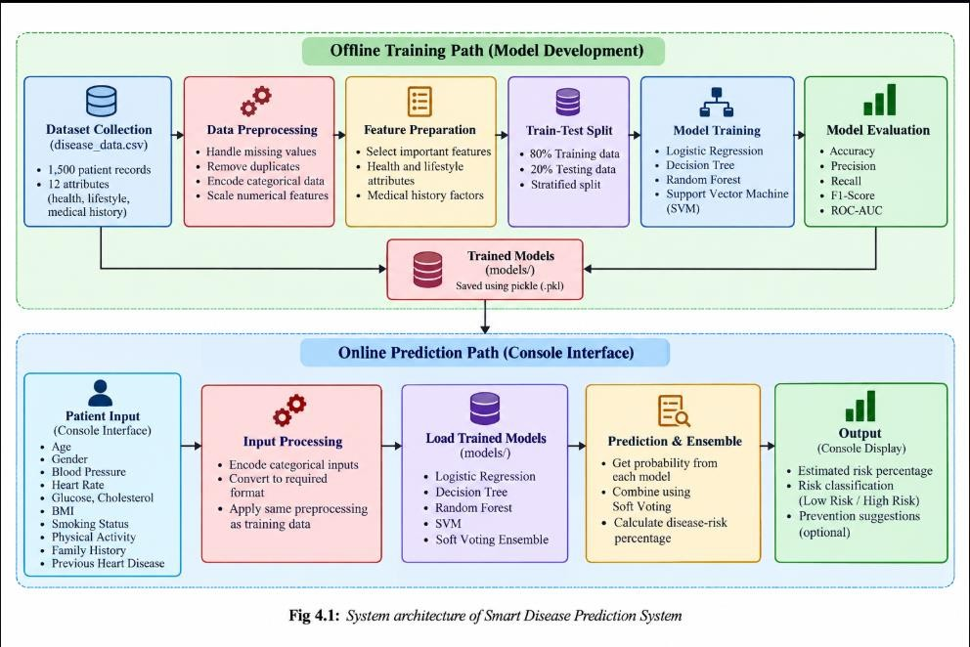

The system architecture consists of multiple stages, including data collection, preprocessing, model training, evaluation, and disease-risk prediction. The dataset is processed to prepare suitable features for training the machine learning models.
Data Processing Layer: The patient dataset is loaded and checked for missing values and duplicate records. Categorical features are encoded, and numerical features are scaled where required.
Feature Preparation Layer: Important health, lifestyle, and medical history attributes are prepared as inputs for the classification models.
Model Training Layer: Logistic Regression, Decision Tree, Random Forest, and Support Vector Machine (SVM) classifiers are trained using the training dataset. A Soft Voting Ensemble combines predictions from multiple models.
Model Evaluation Layer: The trained models are evaluated using Accuracy, Precision, Recall, F1-Score, and ROC-AUC to compare their performance on the test dataset.

Prediction Layer: The console interface collects patient information and passes the processed data to the trained models. The system generates an estimated disease-risk percentage and classifies the result as Low Risk or High Risk.
The complete workflow connects dataset preparation, model development, evaluation, and prediction to provide a simple preliminary disease-risk assessment. The system is intended for educational and health-awareness purposes and does not replace professional medical diagnosis.

CHAPTER 5
DATA PREPROCESSING

Introduction
Raw patient data cannot always be directly used by machine learning algorithms. Health attributes may contain values in different ranges, categorical information, and missing or duplicate records. Data preprocessing is therefore important for preparing consistent input data and improving the reliability of model training. In this project, Pandas is used for data handling, while Scikit-learn provides preprocessing techniques for preparing features. The same preprocessing steps must be applied during training and prediction to maintain consistency.

Handling Missing Values
The patient dataset is checked for missing values before model training. Missing values can affect the quality of the input data and may cause errors during model execution if they are not handled properly. The preprocessing stage identifies incomplete records and applies the handling method implemented in the project. Before prediction, patient inputs are also checked to ensure that the required health parameters are provided. This helps the system process complete and consistently formatted information.

Data Cleaning
Data cleaning prepares the patient dataset for machine learning. The dataset is checked for duplicate records and missing values, and the input features are separated from the target column. The target variable is named target, where 0 represents No Risk and 1 represents Risk. Categorical attributes, such as gender, smoking status, and physical activity, are converted into numerical representations suitable for model training. Numerical attributes are scaled where required. These steps prepare the data for training and evaluating Logistic Regression, Decision Tree, Random Forest, and Support Vector Machine (SVM) classifiers, along with the Soft Voting Ensemble.

Outlier Detection and Range Validation
The patient dataset is checked for unusual values and invalid entries before model training. Health parameters such as age, blood pressure, heart rate, glucose, cholesterol, and BMI should contain reasonable values for meaningful prediction. Invalid or unexpected values can affect the quality of the model input and the resulting prediction. Therefore, the input data should be validated according to the checks implemented in the project. Tree-based models, such as Decision Tree and Random Forest, can capture non-linear relationships in the data, but data quality remains important for reliable results.

Feature Engineering / Encoding
The project uses health, lifestyle, and medical history attributes to prepare the input features for machine learning. Categorical attributes are converted into numerical values, and numerical features are scaled where required. The prepared features are then supplied to the classification models.
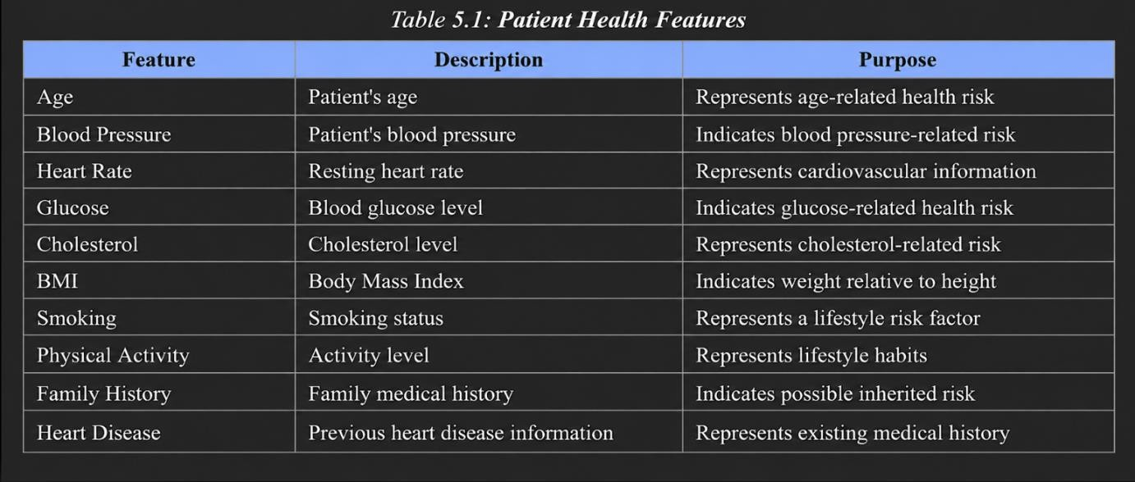
The categorical features are encoded into a numerical format suitable for machine learning. Numerical features are scaled where required. The dataset is divided into training and testing subsets using an 80:20 stratified split. Preprocessing transformations are prepared using the training data and then applied consistently to the testing data to help prevent data leakage.

Data Visualization
Data visualization helps in understanding the distribution of patient health information and the performance of machine learning models. In this project, visual analysis can be used to examine health parameters such as age, blood pressure, glucose, cholesterol, and BMI. Graphs can also be used to compare the performance of Logistic Regression, Decision Tree, Random Forest, SVM, and the Soft Voting Ensemble using evaluation metrics such as Accuracy, Precision, Recall, and F1-Score. These visualizations help in interpreting the dataset and comparing the prediction models.

Train-Test Split
The patient dataset containing 1,500 records is divided into 80% training data and 20% testing data using a stratified split. The training set is used to train the classification models, while the testing set is used to evaluate their performance on unseen records. Stratified sampling helps preserve the distribution of the target classes in both subsets. The classification models, including Logistic Regression, Decision Tree, Random Forest, and Support Vector Machine (SVM), are evaluated using the test data. This process helps compare the models fairly and assess their ability to predict disease risk.

Summary
Data preprocessing prepares the patient dataset for machine learning by checking data quality, handling missing values where required, encoding categorical features, and scaling numerical inputs where necessary. Feature preparation and stratified train-test splitting help organize the data for model training and evaluation. The prepared dataset is used to train and compare multiple classification algorithms, while the Soft Voting Ensemble combines model predictions to generate the final disease-risk estimate. These steps provide the foundation for the methodology and algorithms discussed in the next chapter.

CHAPTER 6
METHODOLOGY AND ALGORITHMS

Introduction
The Smart Disease Prediction System uses supervised machine learning classification to estimate potential disease risk from patient health information. The dataset contains health, lifestyle, and medical history features, with a target variable representing the risk category. Four classification algorithms are used in the project: Logistic Regression, Decision Tree, Random Forest, and Support Vector Machine (SVM). A Soft Voting Ensemble combines predictions from multiple models to generate the final prediction. All models are trained and evaluated using the prepared dataset.

Classification Techniques

Logistic Regression
Working: Logistic Regression is a supervised classification algorithm that estimates the probability of a target class using a logistic function. It learns the relationship between input features and the target variable from the training data. The predicted probability is used to classify the patient into the appropriate risk category.
Advantages: It is simple to implement, computationally efficient, and provides probability estimates. It also serves as a useful baseline for comparing the performance of other classification algorithms.
Application in Project: Logistic Regression is trained using the prepared patient health features to predict disease risk. Its performance is evaluated using metrics such as Accuracy, Precision, Recall, F1-Score, and ROC-AUC.

Random Forest
Working: Random Forest is an ensemble learning algorithm that builds multiple decision trees and combines their predictions to produce the final result. Each tree learns patterns from the training data, and the combined prediction helps improve the stability of the model.

Advantages: It can capture non-linear relationships between health features, handles complex datasets, and generally reduces overfitting compared with a single decision tree.
Application in Project: Random Forest is trained using patient health, lifestyle, and medical history features to estimate disease risk. Its performance is evaluated using Accuracy, Precision, Recall, F1-Score, and ROC-AUC.

Gradient Boosting

support vector machine
Working: Support Vector Machine is a supervised machine learning algorithm that identifies a decision boundary separating different classes. It aims to find a boundary with the maximum margin between the classes. Depending on the selected kernel, SVM can also classify data with non-linear relationships.
Advantages: SVM can work effectively with high-dimensional data and can model complex class boundaries using suitable kernels.
Application in Project: SVM is used to classify patient records based on the prepared health features. Its prediction performance is compared with the other classification models using standard evaluation metrics..

Class Imbalance Handling
Class imbalance occurs when one target category contains significantly more records than another. This can cause a machine learning model to favor the majority class and perform poorly on the minority class.
In this project, the target classes are examined during data preparation. The dataset is divided into training and testing subsets using a stratified split to preserve class proportions. Any resampling technique, if implemented, should be applied only to the training data so that the testing data remains representative of the original distribution. Model performance is then evaluated using Precision, Recall, F1-Score, and other suitable metrics.

Model Evaluation Metrics
- Accuracy — measures the overall proportion of correctly predicted patient risk categories.
- Precision — measures how many patients predicted as at risk actually belong to the positive risk class.
- Recall — measures how many actual positive-risk cases are correctly identified by the model.
- F1-Score — the harmonic mean of Precision and Recall, providing a balanced measure of classification performance.
- ROC-AUC — measures how effectively the model distinguishes between the two target classes across different classification thresholds.
- Confusion Matrix — shows the counts of true positives, true negatives, false positives, and false negatives, helping analyze classification errors.

Risk Score, Categories and Affordability Logic
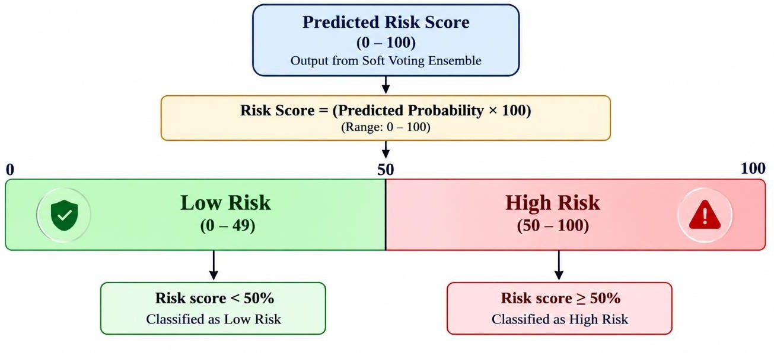
Fig 6.1: Mapping of risk score to risk category

The Smart Disease Prediction System generates an estimated disease-risk percentage based on the predictions of the trained machine learning models. The Soft Voting Ensemble combines the predictions from multiple classifiers to produce the final risk estimate. The output is presented as a percentage from 0 to 100, making the prediction easier to understand.

The predicted risk percentage is classified into two categories: Low Risk and High Risk. Based on the implemented threshold, a risk score below 50% is classified as Low Risk, while a score of 50% or above is classified as High Risk. This classification provides a simple interpretation of the model output and helps users understand the estimated risk level.
The final output is displayed through the console interface and includes the estimated risk percentage and the corresponding risk category. The score represents a model-based estimate from the available patient data and is intended for preliminary risk assessment and health awareness. It is not a confirmed medical diagnosis, and users should consult qualified healthcare professionals for medical advice.

CHAPTER 7
RESULTS AND ANALYSIS

Introduction
This chapter presents the performance evaluation of the machine learning models implemented in the Smart Disease Prediction System. Logistic Regression, Decision Tree, Random Forest, and Support Vector Machine (SVM) are compared using the prepared test dataset. The results are analyzed using standard evaluation metrics to understand how effectively each model predicts disease-risk categories. The Soft Voting Ensemble is also considered to evaluate the combined predictions of multiple classifiers.

Experimental Setup
The dataset containing 1,500 patient records is divided into 80% training data and 20% testing data using a stratified split. The training data is used to fit the machine learning models, while the testing data is used to evaluate their performance on unseen records. Data preprocessing and feature preparation are applied according to the implemented workflow. The models are evaluated using Accuracy, Precision, Recall, F1-Score, and ROC-AUC. The results are used to compare the individual classifiers and the Soft Voting Ensemble.

Logistic Regression Results
Logistic Regression is evaluated using the prepared test dataset to measure its ability to classify patient disease risk. Its performance is assessed using Accuracy, Precision, Recall, F1-Score, and ROC-AUC. These metrics indicate the proportion of correct predictions, the reliability of positive-risk predictions, and the model's ability to identify positive-risk cases. The results are compared with those of the other classification algorithms to understand the strengths and limitations of Logistic Regression.

Random Forest Results
Random Forest is evaluated on the same test dataset to compare its performance with Logistic Regression and the other classifiers. By combining predictions from multiple decision trees, the algorithm can capture complex relationships between patient health attributes. Accuracy, Precision, Recall, F1-Score, and ROC-AUC are used to assess its classification performance.

The results help determine how effectively Random Forest identifies disease-risk patterns in the patient dataset.

Support Vector Machine (SVM)
Support Vector Machine (SVM) was evaluated using the prepared test dataset to measure its ability to classify patient disease risk. Its performance was analyzed using Accuracy, Precision, Recall, F1-Score, and ROC-AUC. These metrics help assess the model's overall prediction accuracy and its ability to identify patients belonging to the positive-risk class. The results are compared with Logistic Regression, Decision Tree, and Random Forest to understand the effectiveness of SVM in the Smart Disease Prediction System.

Key Findings
    - The classification models are evaluated using Accuracy, Precision, Recall, F1-Score, and ROC-AUC to measure their ability to predict disease-risk categories.
    - Logistic Regression, Decision Tree, Random Forest, and Support Vector Machine (SVM) are compared to identify their strengths and limitations in disease-risk prediction.
    - The Soft Voting Ensemble combines predictions from multiple classification models to generate the final risk estimate.
    - Model performance depends on the quality of the dataset, feature preparation, preprocessing methods, and the distribution of target classes.
    - The dataset is divided into training and testing subsets using an 80:20 stratified split. Evaluation on the test data helps assess model performance on unseen records.
    - The system is an academic prototype intended for preliminary disease-risk assessment and health awareness. Its predictions do not replace professional medical diagnosis, and further validation is required before real-world clinical use.

CHAPTER 8
OUTPUT SCREENS
This chapter presents the user-facing outputs of the system. The figures below should be replaced with screenshots taken from the running application (http://localhost:8000/) and the evaluation command output.

Assessment Console
The home page introduces the Smart Disease Risk Prediction System and provides navigation options for Risk Assessment, Model Comparison, and About. It displays an overview of the system, the number of health parameters, the classification models used, and the Soft Voting Ensemble. Users can start a new assessment or view the model performance results.
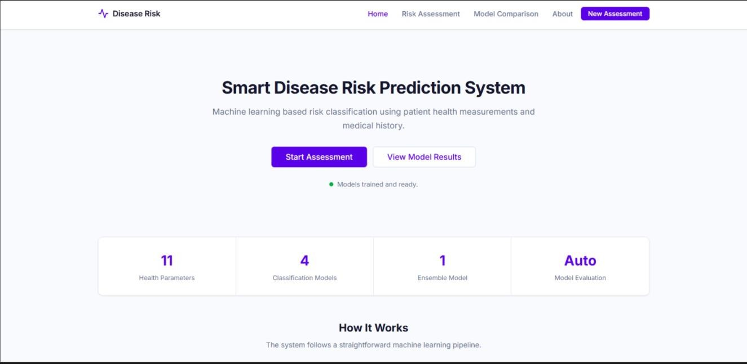

Assessment Result
The Risk Assessment page collects patient information, including age, gender, blood pressure, heart rate, glucose, cholesterol, BMI, smoking status, physical activity, family history, and previous heart disease. The entered information is used by the trained machine learning models to generate a disease-risk prediction.

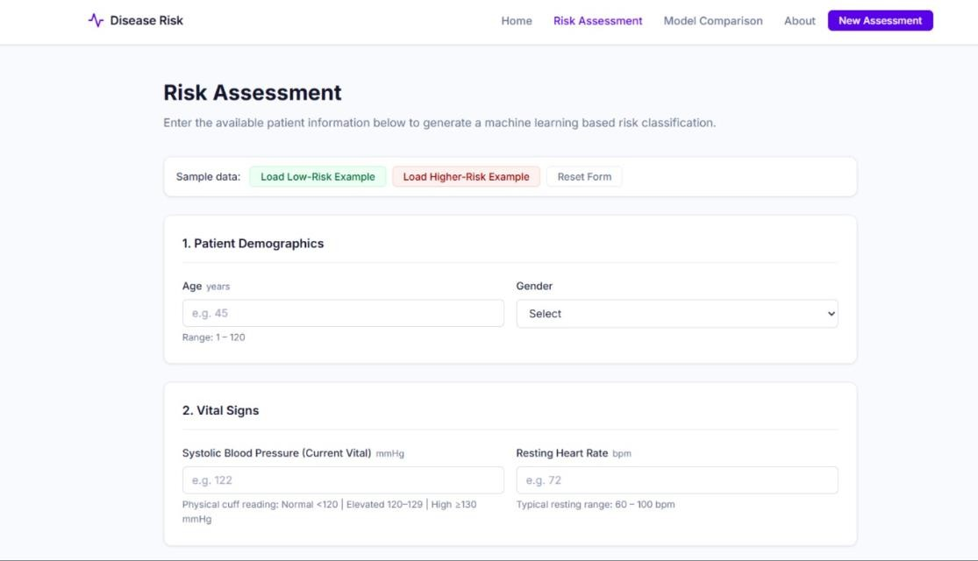
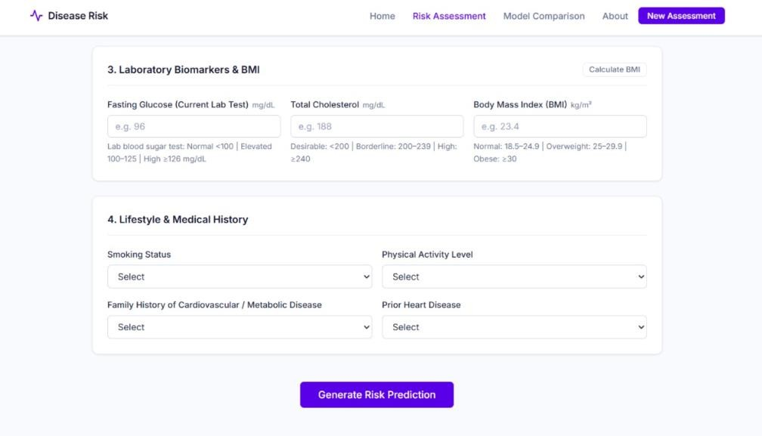

Model Performance and Comparison
The Model Comparison page displays the performance of Logistic Regression, Decision Tree, Random Forest, Support Vector Machine, and the Soft Voting Ensemble. The results include Accuracy, Precision, Recall, F1-Score, and ROC-AUC. Graphs and tables help users compare the classification models and understand their predictive performance.
.
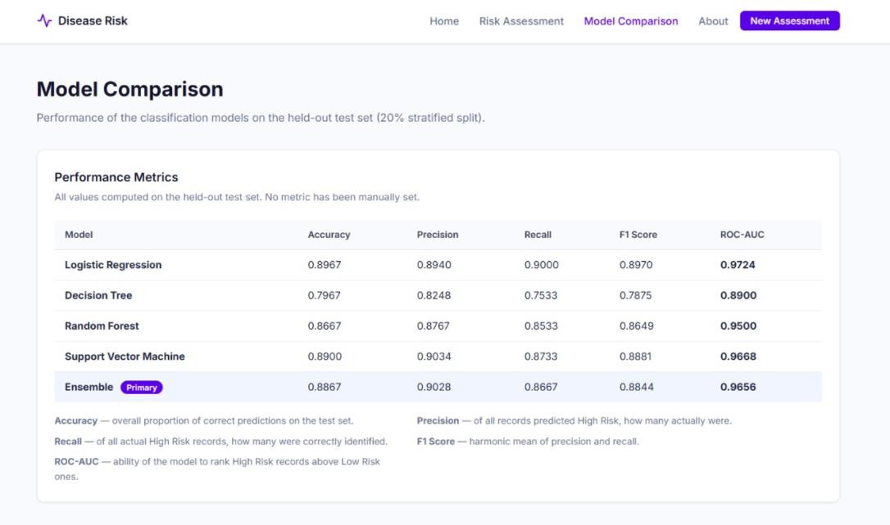
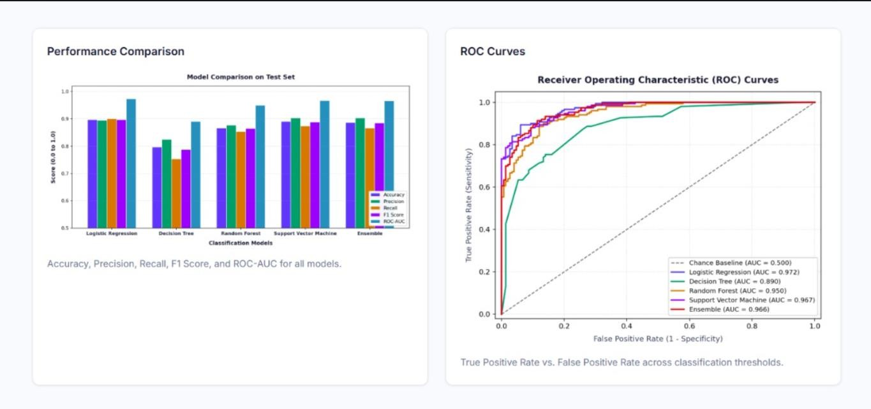

CHAPTER 9
CONCLUSION
This project developed the Smart Disease Prediction System with Model Ensemble, a machine learning-based application designed to estimate potential disease risk using patient health, lifestyle, and medical history information. The system uses a dataset containing 1,500 patient records and applies data preprocessing and feature preparation before training the classification models. Logistic Regression, Decision Tree, Random Forest, and Support Vector Machine (SVM) are trained and evaluated to compare their performance in disease-risk prediction.
The system uses a Soft Voting Ensemble to combine predictions from multiple classification models and generate a final risk estimate. Model performance is evaluated using Accuracy, Precision, Recall, F1-Score, and ROC-AUC. The web interface provides a home page, patient health information input form, model performance visualization, and model comparison results. These features make the system easier to use and help users understand the estimated risk classification.
The practical value of this project is its ability to provide a quick and consistent preliminary disease-risk assessment based on available patient information. However, the system is an academic prototype and its predictions depend on the quality and representativeness of the dataset and the performance of the trained models. Further testing, validation on diverse patient data, and improvements in model reliability are required before real-world clinical use. The system is intended for health awareness and preliminary assessment only and cannot replace professional medical diagnosis or advice.

CHAPTER 10
FUTURE SCOPE
- Dataset Expansion: Expand the dataset with larger and more diverse patient records to improve the reliability and generalization of disease-risk predictions.
- Model Validation: Use cross-validation and external datasets to evaluate model performance more thoroughly and verify its ability to predict disease risk on unseen patient data.
- Advanced Machine Learning Models: Explore additional classification algorithms, ensemble techniques, and hyperparameter tuning to improve prediction performance.
- Explainable AI: Integrate Explainable Artificial Intelligence (XAI) techniques to help users understand which health parameters contribute to the predicted risk.
- Additional Health Parameters: Include more relevant medical indicators, lifestyle factors, and patient history information to support broader risk assessment.
- Improved User Interface: Develop a more interactive dashboard with detailed patient reports, model performance charts, and clear risk summaries.
- Secure Data Management: Add authentication, authorization, encryption, and secure storage to protect sensitive patient information.
- Continuous Model Monitoring: Monitor model performance and periodically retrain models when new, reliable patient data becomes available.
- Web and Mobile Deployment: Extend the application into a responsive web and mobile platform to make preliminary disease-risk assessment more accessible.
- Clinical Validation: Collaborate with qualified healthcare professionals and validate the system using appropriate clinical data before considering real-world medical applications.

CHAPTER 11
REFERENCES
- F. Pedregosa et al., “Scikit-learn: Machine Learning in Python,” Journal of Machine Learning Research, vol. 12, pp. 2825–2830, 2011.
- C. M. Bishop, Pattern Recognition and Machine Learning. Springer, 2006.
- L. Breiman, “Random Forests,” Machine Learning, vol. 45, no. 1, pp. 5–32, 2001.
- D. W. Hosmer, S. Lemeshow, and R. X. Sturdivant, Applied Logistic Regression, 3rd ed. Wiley, 2013.
- C. Cortes and V. Vapnik, “Support-Vector Networks,” Machine Learning, vol. 20, pp. 273–297, 1995.
- T. G. Dietterich, “Ensemble Methods in Machine Learning,” in Multiple Classifier Systems,
pp. 1–15, 2000.
- F. Pedregosa et al., “Scikit-learn: Machine Learning in Python,” Journal of Machine Learning Research, vol. 12, pp. 2825–2830, 2011. Scikit-learn documentation.
- World Health Organization, “Cardiovascular diseases (CVDs),” WHO. Available: https://www.who.int/news-room/fact-sheets/detail/cardiovascular-diseases-(cvds).
- Pandas Development Team, “Pandas Documentation.” Available: https://pandas.pydata.org/docs/.
- NumPy Developers, “NumPy Documentation.” Available: https://numpy.org/doc/.
- Python Software Foundation, “Python Documentation.” Available: https://docs.python.org/3/.
- Scikit-learn Developers, “Ensemble Methods: Voting Classifier.” Available: https://scikit-learn.org/stable/modules/ensemble.html.

